2024 Show Schedule
Jennifer Scott Fine Art – Created to Create Studios, LLC
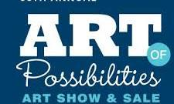
ART OF POSSIBILITIES
Golden Valley Minnesota: May 16 – June 21
https://courageart.org/art-show-sale-opening

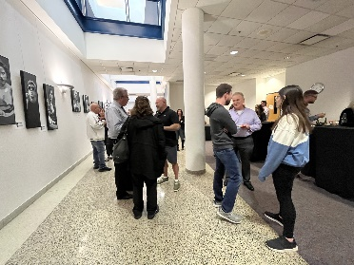
NVISION GALLERY
986 Civic Center Drive – Niles, Illinois
Opening Event: May 2, 2024
5:00 PM – 8:00 PM
Show runs through: June 19, 2024

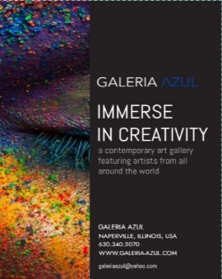
GALERIA AZUL
239 South Washington – Naperville, Illinois
Opening Event: June 1, 2024
12:00 PM – 3:00 PM
Show runs through: TBD
https://www.galeria-azul.com/

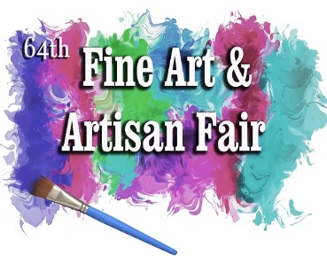
NAPERVILLE FINE ART & ARTISAN FAIR
June 29, 2024 - June 30, 2024
10:00 AM - 5:00 PM
Naper Settlement
523 S. Webster, Naperville, IL

DOWNERS GROVE FINE ART FESTIVAL
September 7, 2024 – September 8. 2024
10:00AM – 5:00 PM
933A Curtiss Street, Downers Grove, Illinois

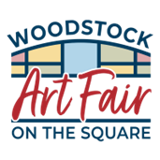
WOODSTOCK ART FAIR ON THE
September 21, 2024 – September 22, 2024
10:00 AM – 5:00 PM
100 S Johnson Street, Woodstock, Illinois

